Contents
Summary 1
Setup and Configuration 1
Windows 1
Mac 1
Linux 1
Chromebook 1
Android 1
SHIELD Android TV 1
HTML 1
More Information 1

Summary
This article provides information on how to connect to your VDI desktop.

Setup and Configuration
We have instructions here for Windows, Mac, Linux, Chromebook, Android, and SHIELD Android TV.
You can download the Horizon View client for your specific platform from the following locations:
- Navigate to view.nvidia.com, select “Install VMware Horizon Client” to be taken to the download page.
- Connect to \\mis1\apps\VM\Horizon_Client\ and retrieve the installer
- On Windows, you can install through Software Center. On Mac OS X, you can install through Self Service.

Here is a basic guideline on how to connect to VDI. For detailed instructions, use the table of contents to navigate to the section for your specific platform.
- Request an account if you don’t already have one. Contact the help desk to request one.
- Download the VMware Horizon View client from https://view.nvidia.com
- Install the client
- Launch the VMware Horizon View client
- Enter the server name view.nvidia.com
- If you’re connecting externally, enter your username and RSA Token
- Enter your NVIDIA username and password
- Double click the HQ vGPU Workstation icon to launch your VDI.

Windows
Through the installer, follow these screenshots and choose defaults for any screens that are not shown.
Select IPv4 and click Next
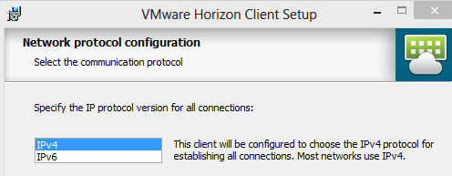

Leave the default features selected
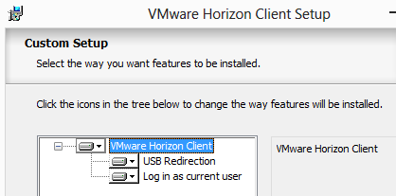

When prompted for the connection server details, enter view.nvidia.com and click Next
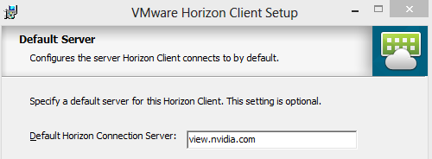

Select the checkbox for “Set default option to login as current user” and click Next
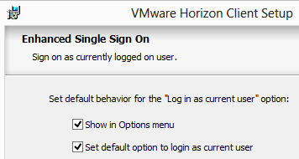

Select your shortcut options, click Next, then click Install
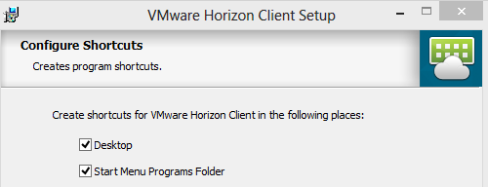

You may need to restart after completing the installation.
Open the VMWare Horizon Client and double click on the view.vdi.com connection.
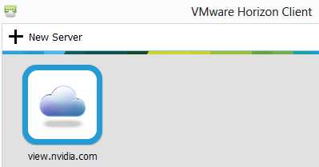

Authenticate using your domain credentials to access your available resources list. If you are logged in the corporate network and have already selected “login as current user”, you will not have to type in credentials.
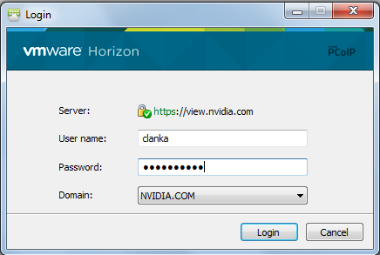
If you are connecting from outside the corporate network, you will be prompted for your RSA credentials before you get to the domain authentication page. The Passcode field is your PIN + SecureID Passcode for hard tokens, or just your passcode for soft tokens.
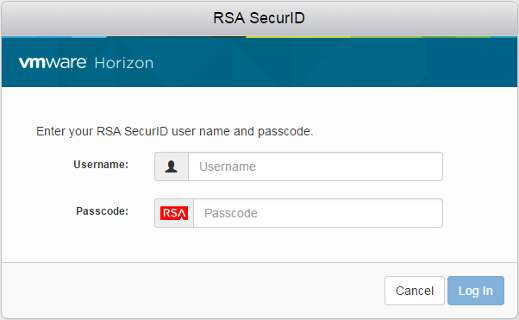
Double-click “HQ vGPU Workstation” to start using your virtual desktop

Mac
Once you have downloaded the Client for OS X, you can begin the installation by launching the .dmg file that you downloaded, you will be prompted to Click agree to accept the Licensing Agreement.
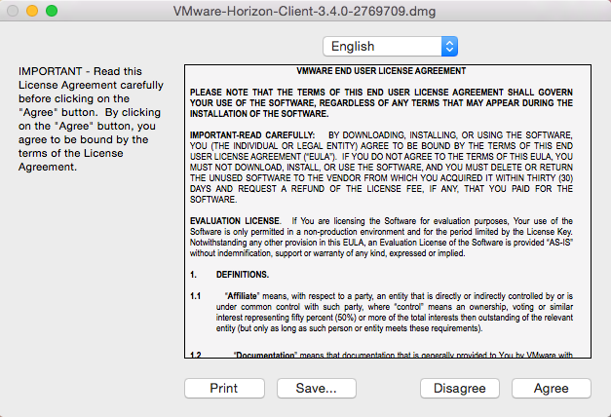

Once you agree, you will need to drag the Horizon Client.app icon to the folder icon on the right side of the window. This will add the Horizon Client to your Applications.
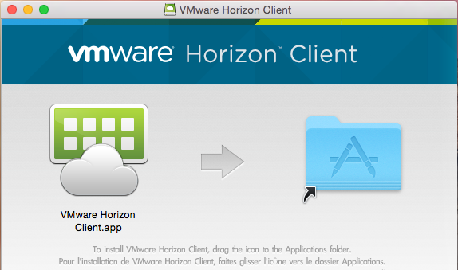

Once the application has been installed, you can find it from the Applications menu. You can pin the application to your Dock for easy access. When you launch the Client for the first time, you will receive a warning. Click Open.
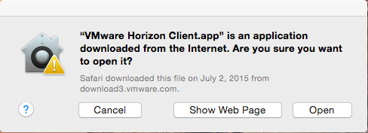

Once the client is open, you should be prompted to enter the server connection details. If not, click the New Server icon to begin configuration.
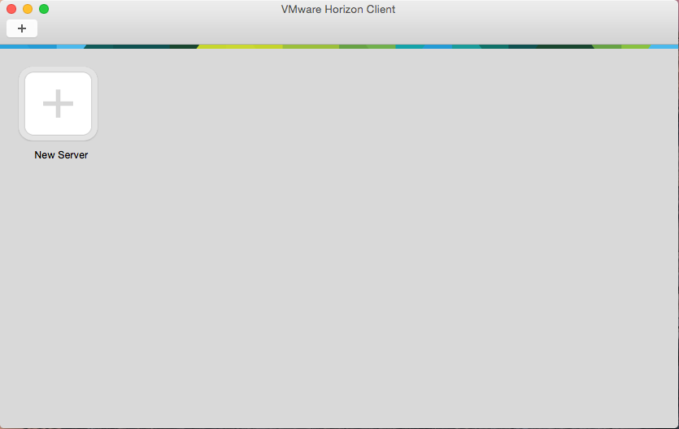

Enter the name of the connection server into the provided field. You can check or uncheck the Always connect at launch (your preference) and click Connect.
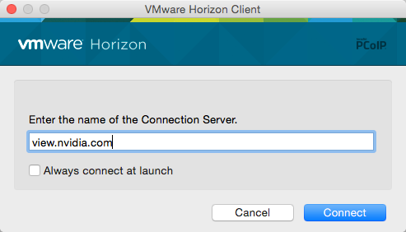

Enter your domain credentials into the provided fields.
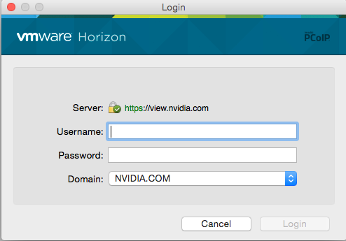

If you are connecting from outside the corporate network, you will be prompted for your RSA credentials before you get to the domain authentication page. The Passcode: field is your PIN + SecureID Passcode for hard tokens, or just your passcode for soft tokens.
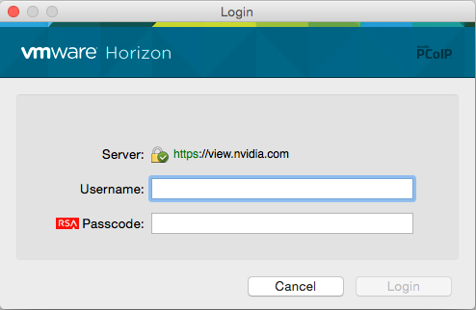

If you unchecked the box to always connect on launch above, you will see a list of desktop resources based on your group membership, and can launch the preferred desktop.
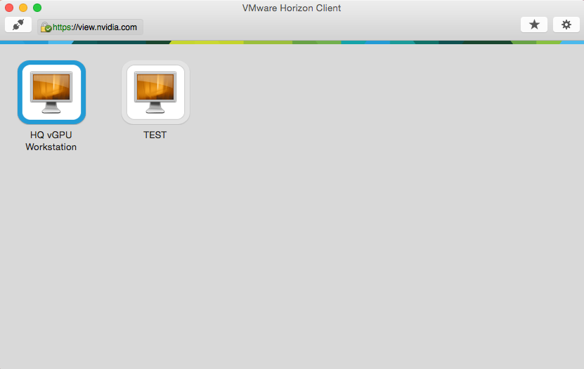

Once your desktop is connected, you can move your mouse to the top of the screen to display the menu options available for the Horizon Client.
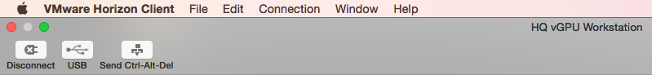

Linux
- Navigate to https://view.nvidia.com in your browser, click on "Install VMware Horizon Client"
- From there you will be able to download the Linux client (.bundle file)
- You may have to set executable permission on the file (chmod +x)
- Once you open the bundle file, the installer will appear.
- Choose the components you would like to install. We recommend checking all components. The "Client Drive Redirection" feature is currently a Tech Preview so it may not work as expected.
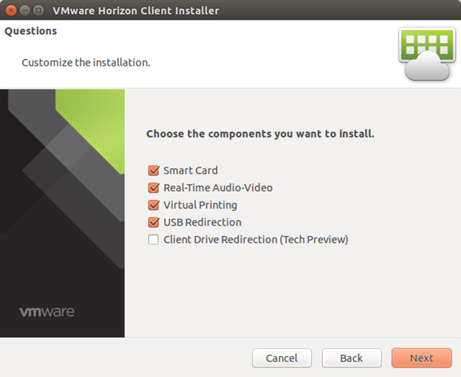
- Click Next.
- The installer will show what products are ready to be installed, click Install.
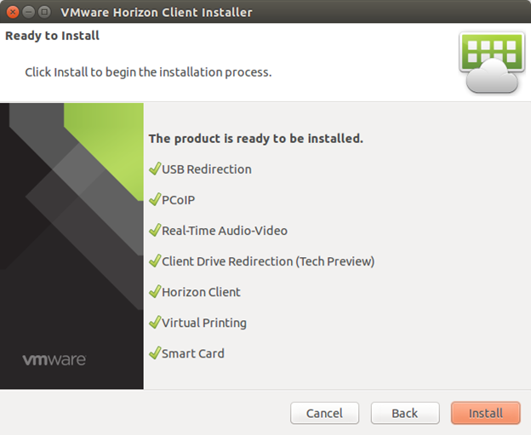
- Read through the EULA, and accept if all looks good.

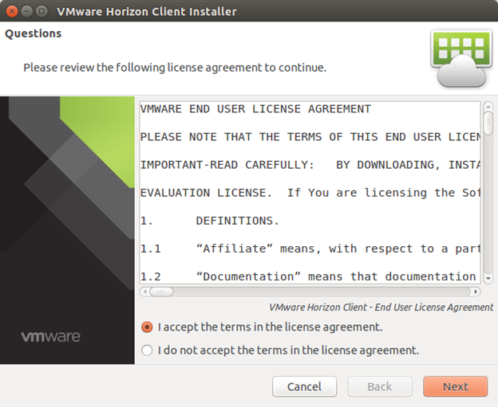
- Check the box to "Register and start installed service(s) after the installation.
- Click Scan
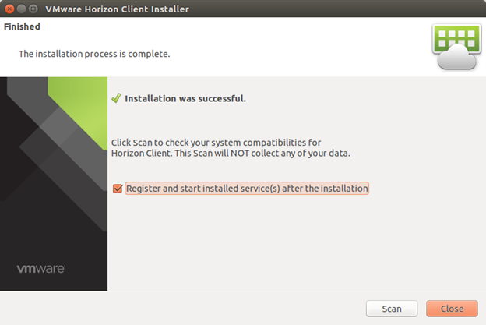
- The scan results will show you what components are working.

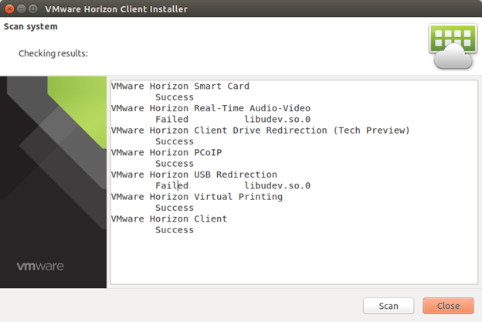
- You may have to install some missing dependencies then scan again.
With Ubuntu 14.04 you can download libudev here http://mirrors.kernel.org/ubuntu/pool/main/u/udev/libudev0_175-0ubuntu9_amd64.deb
And install by running: sudo dpkg -i libudev0_175-0ubuntu9_amd64.deb
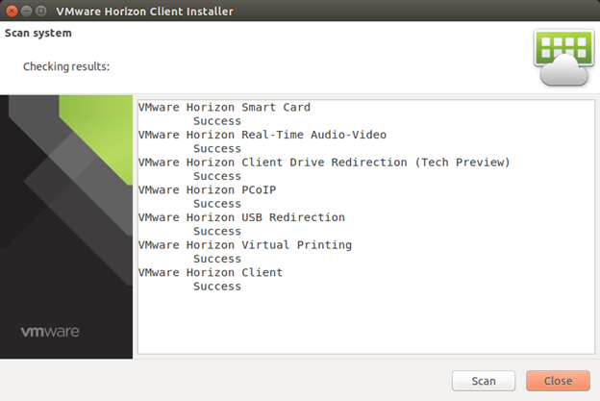
- Close! You can now start using the Horizon client.
- When launching the Horizon client, enter the server address of view.nvidia.com when prompted.
- Select your vGPU Workstation to launch VDI.

Chromebook
Please follow the steps below to install the VMWare Horizon Client on your Chromebook
- Click the magnifying glass and then click Web Store
- Search the web store for "VMware Horizon"
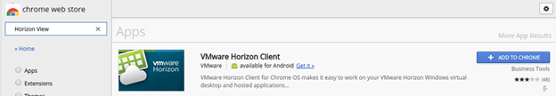
- Click the "Add to Chrome" button to add the application to your Chromebook
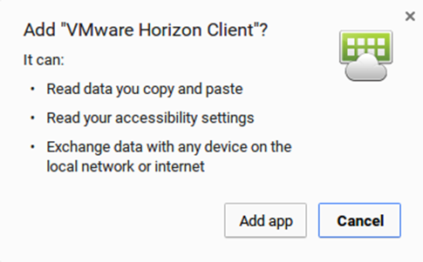
- Click "Add app" to install the application
- After install, launch the VMWare Horizon Client
- For the view server, enter: view.nvidia.com (a description can be entered, but this is optional)
- Click "Connect"
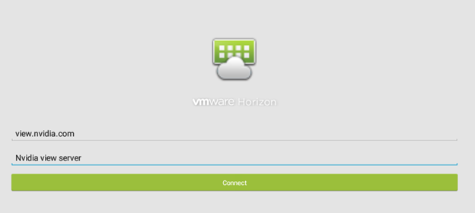
- Double-click the icon for "HQ vGPU Workstation"
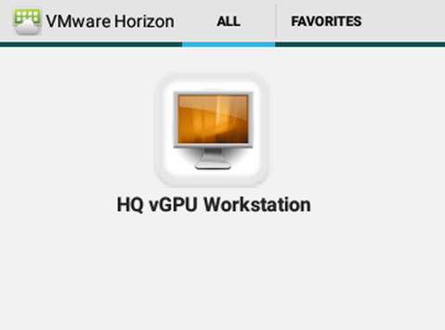
- Enter your Nvidia username and password and click "Connect"
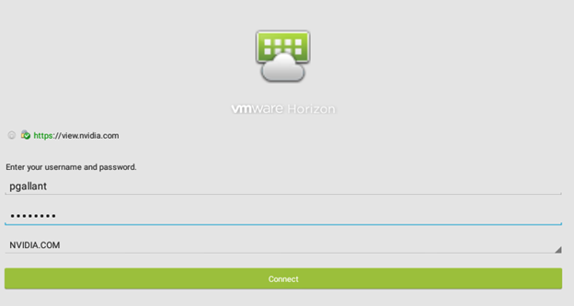
- You should now be connected to your VDI workstation

Android
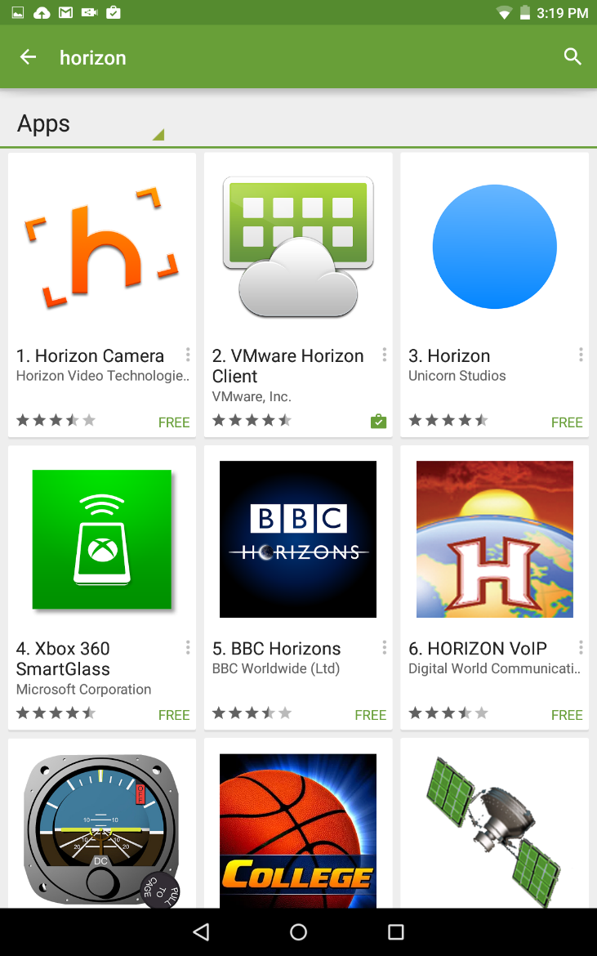

Visit the Google Play Store from your Android device. Search for the VMware Horizon Client and install it on your Android device.

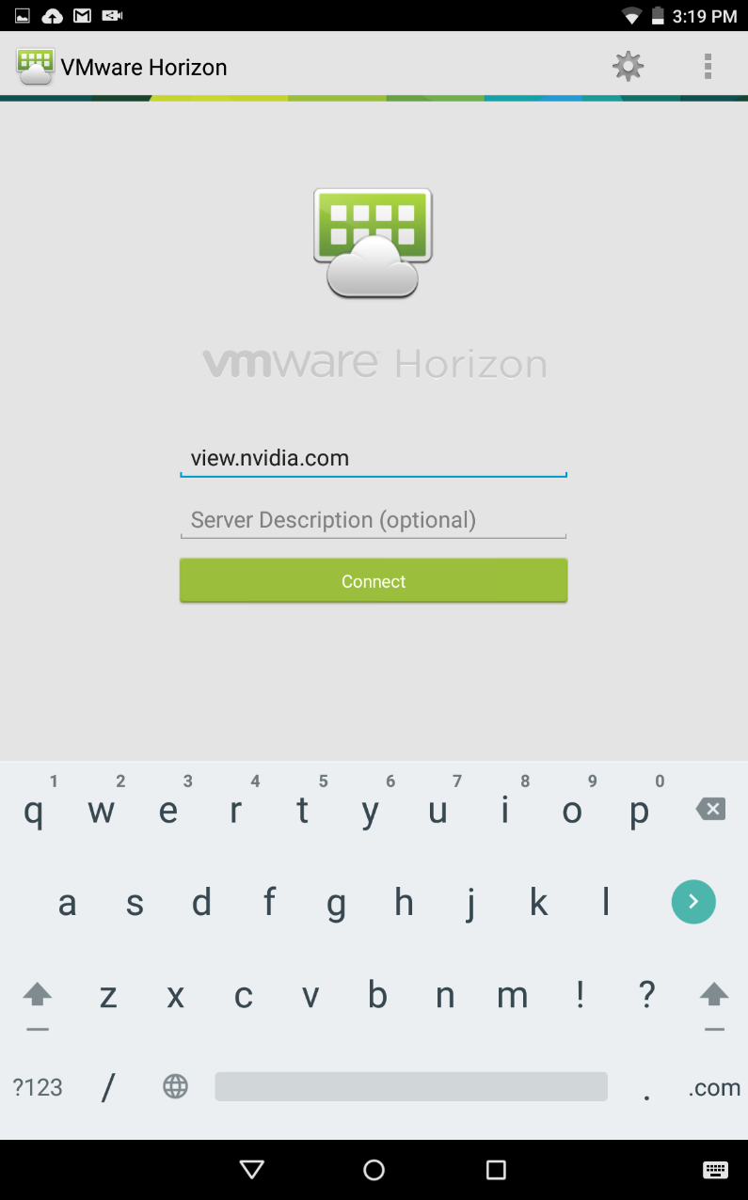

Launch the VMware Horizon Client. Once the client is open, you should be prompted to enter the server connection details.
Enter view.nvidia.com into the provided field and click Connect.

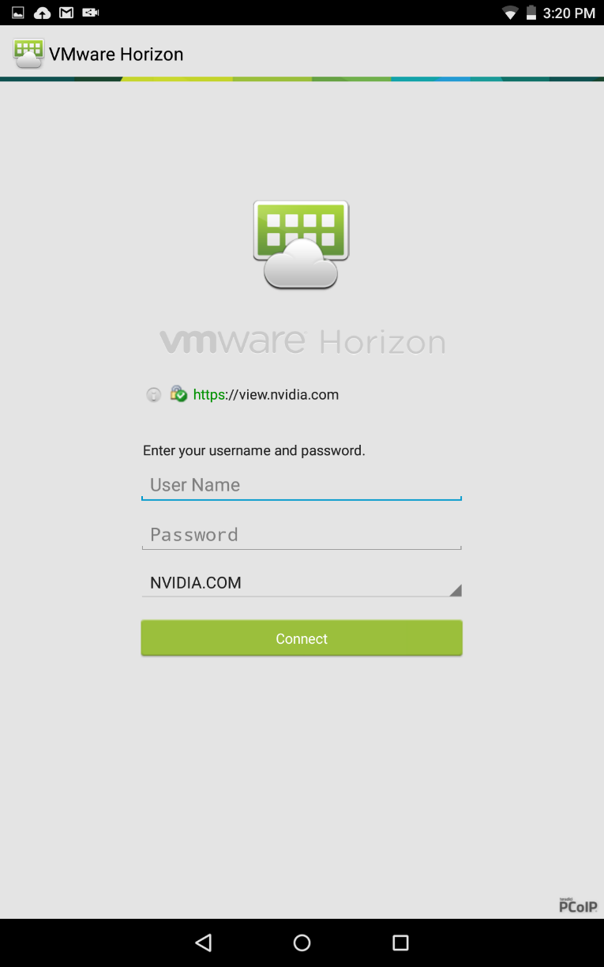

Enter your domain credentials into the provided fields.

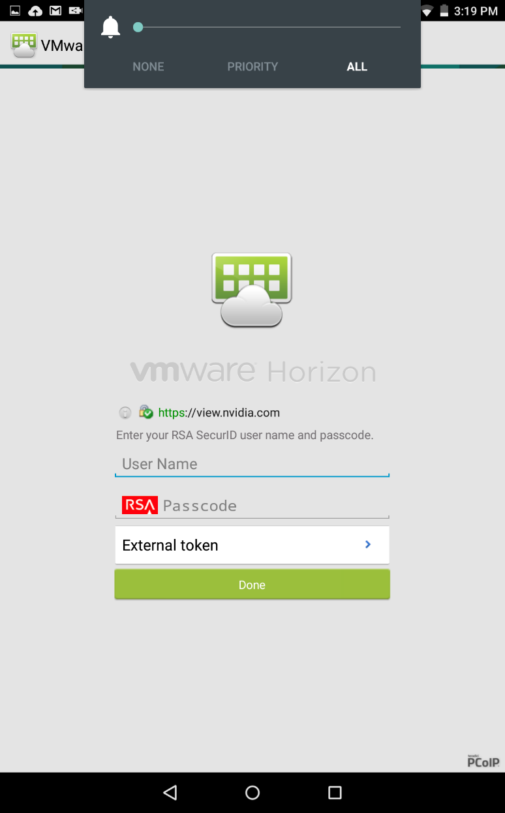

If you are connecting from outside the corporate network, you will be prompted for your RSA credentials before you get to the domain authentication page. The Passcode: field is your PIN + SecureID Passcode for hard tokens, or just your passcode for soft tokens.

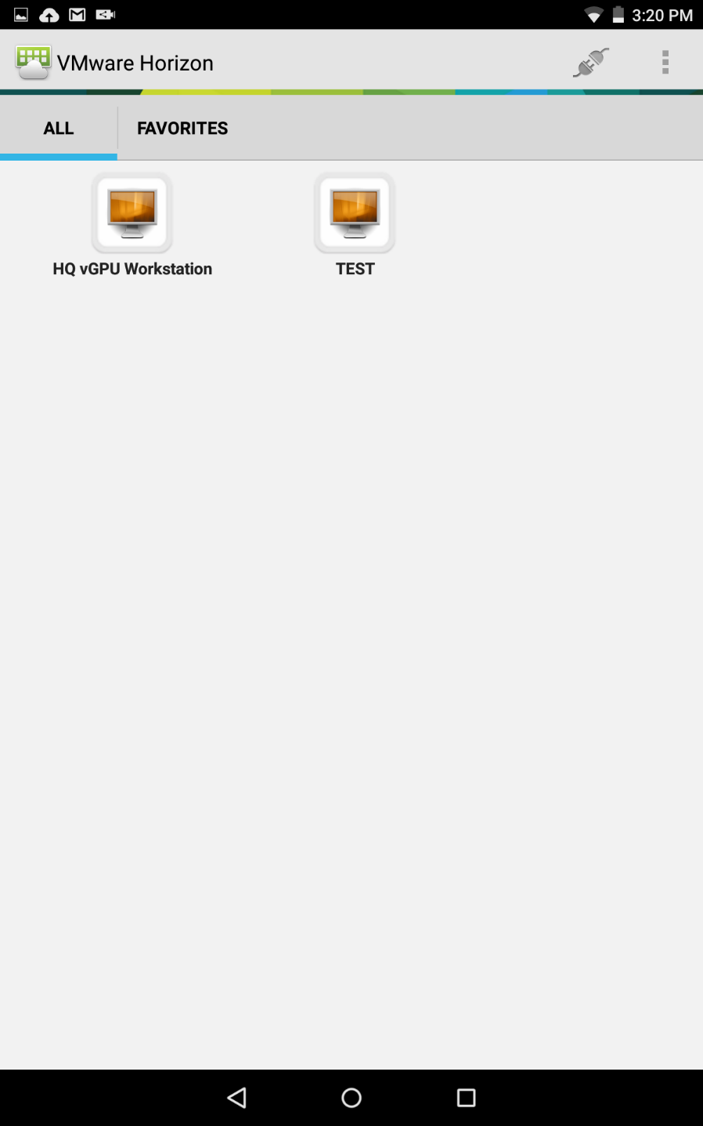

You will see a list of desktop resources based on your group membership, and can launch the preferred desktop.

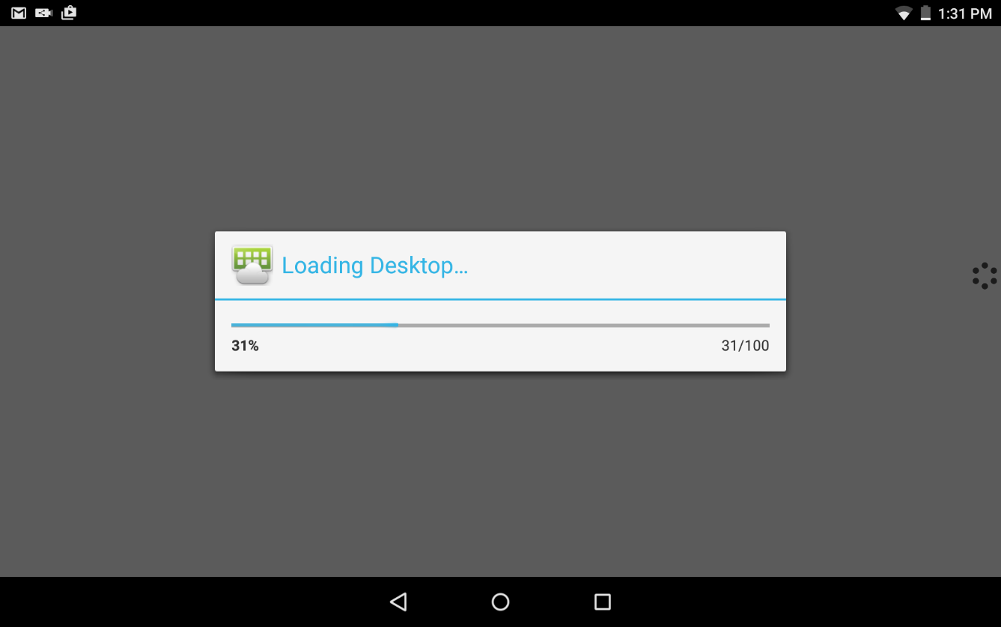

After choosing a desktop (or completing the initial login if the always connect at launch box was checked) you will see a progress bar as your desktop is being connected.

SHIELD Android TV
Requirements:
Hardware
- Nvidia Shield Console
- USB stick (256MB and above, formatted with FAT32)
- USB Keyboard and Mouse ( For using the View Session )
Software
- VMware View Client Android
- ES File Explorer ( Install from Google Play Store )
Procedure:
On your PC / Laptop
- Connect the USB stick to your laptop and format it with FAT32 file system
- Download VMware View Client for Android
- Copy the downloaded .apk file to the USB stick
On Shield Console
- Using the accessory ( Remote or Controller ), search for and install the “ES File Explorer” App from Google Play Store
- Enable “Unknown Sources” under Settings > Security & restrictions
- Connect the USB Stick to Shield Console and using the “ES File Explorer” app locate the USB Stick and select the APK file from before.
- Accept the license agreement and install the App.
- Once the App is successfully installed, eject the USB stick from the Settings > Storage menu and remove the USB stick from the Shield Console.
- Launch the Horizon View client. You can find it in the Settings > Apps menu.

HTML
When possible, we recommend using the Horizon client for the best experience
Please visit https://view.nvidia.com from your browser of choice and select “VMWare Horizon HTML Access”
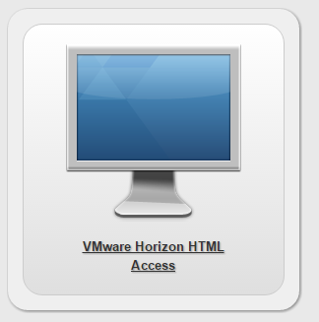

If you are connecting from outside the corporate network, you will need to enter your RSA credentials.
After entering your RSA credentials (if applicable), you will authenticate using your AD credentials.
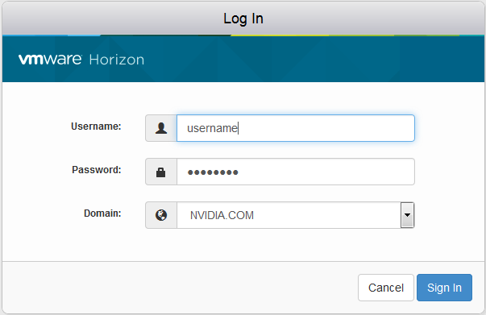

Click on the HQ vGPU Workstation icon to connect to your View Desktop. It will open inside your browser tab and remain running within the browser for the duration of the session.
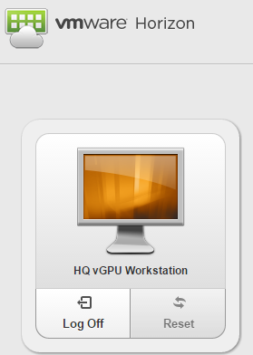

More Information
If this article has not answered your questions or you are experiencing a problem with this service, please submit an incident here: http://Ithelp/create_incident.do

